**Albion Morina**

Department of Computer Science & Media Technology

Linnaeus University

am224ut@student.lnu.se

# Introduction

According to Liu et al. (2007), Mashup is a hallmark of Web 2.0 and attracts both industry and academia recently. It refers to an ad hoc composition technology of Web applications that allows users to draw upon content retrieved from external data sources to create entirely new services (Liu et al., 2007). I have created a service mashup that generates data from Wikipedia through the Wikipedia API that is free for us to use. The API allows us to directly access Wikipedia data in our case via the Hypertext Transfer Protocol (HTTP) and provides an efficient way for users to programmatically search for material information. According to Meng et al. (2018), application programming interfaces (APIs) expose services or data provided by a software application through a set of predefined resources, such as methods, objects, or URIs.

In project we can search for everything we want while we are working. Then, through the search button, all the data and information about the article we need will be displayed. This provides developers with code-level access to the entire Wikipedia reference. The purpose of this API is to provide direct, high-level access to data contained in MediaWiki databases. Client programs can use the API to login, retrieve data, and post changes. In our case, we are just taking data from Wikipedia and using it for different purposes.

In addition to Wikipedia's API, I also used and made a simple Weather app that requires you to write the name of the city, and then through the OpenWeatherMap API, the app shows us the weather in every city in the world. The OpenWeatherMap API currently provides a wide variety of weather data including (but not limited to) current weather, forecasts, historical, weather stations, and weather alerts. While at the beginning of the application we used API Auth0. Auth0 exposes APIs for developers to consume in their applications. The author has accessed these APIs with a simple form where you are asked to log in through various applications such as: Gmail, Twitter, Github, Facebook, Apple account and Microsoft account. and then after you provide your details, the app gets the users API and login to the app.

# Problem definition: Approach to solving the given problem and tasks

A mashup service is a type of web application that combines data or functionality from multiple sources into a single, integrated experience. The problem definition for a mashup service would depend on the specific goals and requirements of the service. The specific needs or problems that our mashup service aims to address, such as providing easy access to a variety of data sources or streamlining a particular process.

We have leveraged Wikipedia API, OpenWeatherMap API and Auth0 APIs. The functionalities or features that the service will offer are different. Wikipedia provides developers with code-level access to the entire Wikipedia reference and how these will help to solve the identified problem or to meet the needs of the target audience. According to Nakayama et al. (2008), Wikipedia has become an invaluable corpus for research in various areas such as AI, NLP, Web mining and Semantic Web since it is a database storing all human knowledge that covers a huge number of concepts of various fields. Wikipedia research can be categorized by the purpose; semantic relatedness measurement (association thesaurus construction), semantic relation extraction (ontology construction), bilingual dictionary extraction etc (Nakayama et al., 2008). While for obtaining data about the weather in different cities of the world, the author has used the OpenWeatherMap API.

According to Musah et al. (2022), Weather forecast-based sources, such as the OpenWeatherMap API, also provide through an API large amounts of data for the current time (analysis) and for future days based on real-time generated forecasts. They also stated the OpenWeatherMap API is an online meteorological service which provides weather data that includes forecasts and current analysis data to researchers and developers of web-based services and mobile applications. As a very complex and very interesting part that the author has used in this task is authentication through APIs. The author has used the Auth0 API and the user can log in using their social networks.

Unfortunately, authentication between people and their devices is both infrequent and persistent. Should a device fall into the wrong hands, the imposter has the full rights of the legitimate user (Corner & Noble, 2003). They also stated so far that authentication requires that a user supply some proof of identity—via password, smartcard, or biometric—to a device.

Based on the problem statement presented above, our research questions can be formulated as follows:

* What can you do with Wikipedia API?
* What can we do to improve the capability to predict weather and extreme weather events through API?
* Which is the most important aspect of authentication?

# Methodology approach:

My methodology generally follows the qualitative research approach, where I rely on data obtained from different applications and the purpose of my research is to answer questions such as what can we do with the Wikipedia API, can we predict the weather for the next few days using the API and to protect ourselves from the dangers that the weather may bring. What is authentication? Why did I use the Auth0 API? What are the advantages and disadvantages that authentication can bring. Attached below I will present my work through different images and giving clarifications about the work that the author has done during the research and completion of his work.

# Outcomes/Analysis of results

The author will start by presenting the initial view of what his project looks like at the beginning. At first, a simple navbar is presented where we have two menus weather and wikipedia. Then a simple text is presented about authentication and their api that the author used.

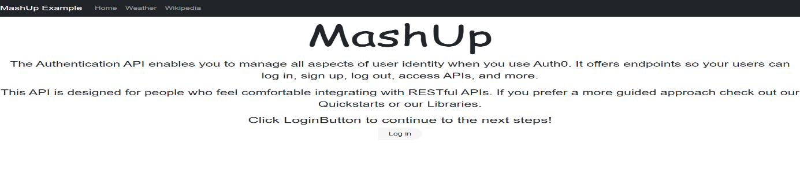

Figure The initial view of the mashup project

Then we have a simple login button below. After clicking on it, it directs us directly to another page that is presented as below.

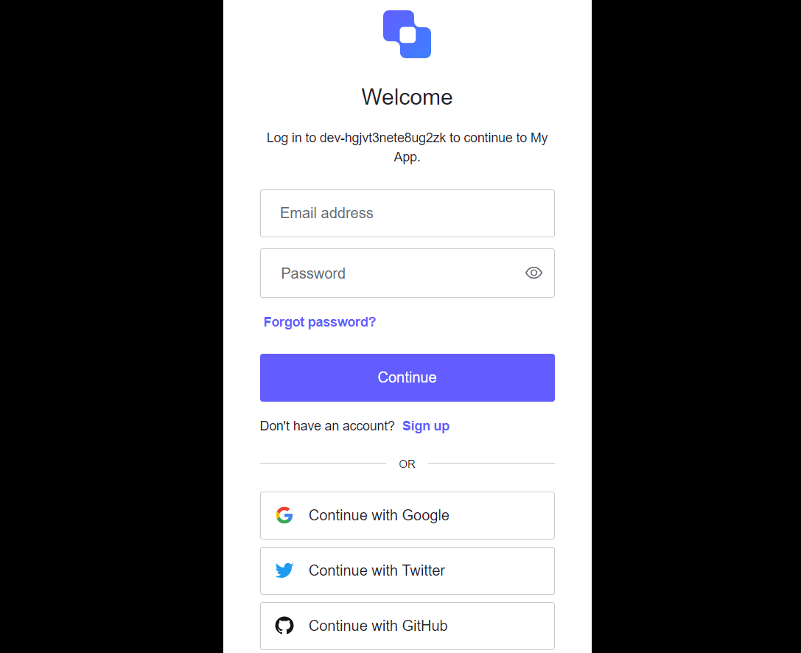

Then through the Auth0 API we can log in using Gmail, Facebook, Github accounts or any other application. When we log in, for example through Gmail, our application goes to another page where it shows our data through the API shown below.

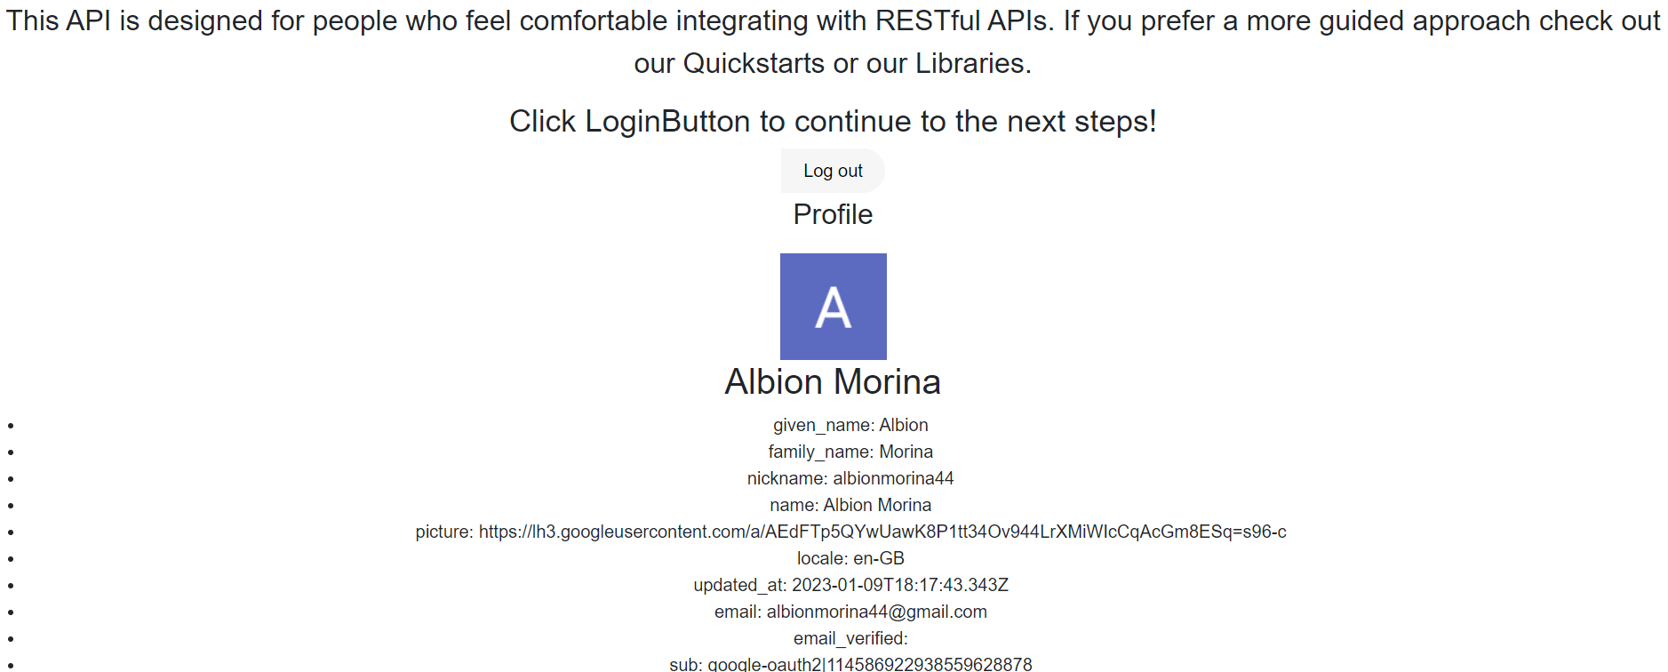

Figure View of our service after login

On the next page, after logging in, we can see all the data that the user has entered, such as: first name, last name, nickname, email, etc. Also, he/she can log out after finished with it.

As a second case, we have APIs that show the weather in real time in every city in the world. But, at the beginning, the author will present the initial view of the Weather API menu.



Figure Initial weather view

While after searching for a city in the given label, using OpenWeatherMap API we access this API and get the data about the weather found in Malmo.



Access to the OpenWeatherMap API is done through the following code.



Meanwhile, at the end we will present the Wikipedia API, where we can search for different materials that Wikipedia possesses and through their API they present us with data in our page about the articles that we are looking for.

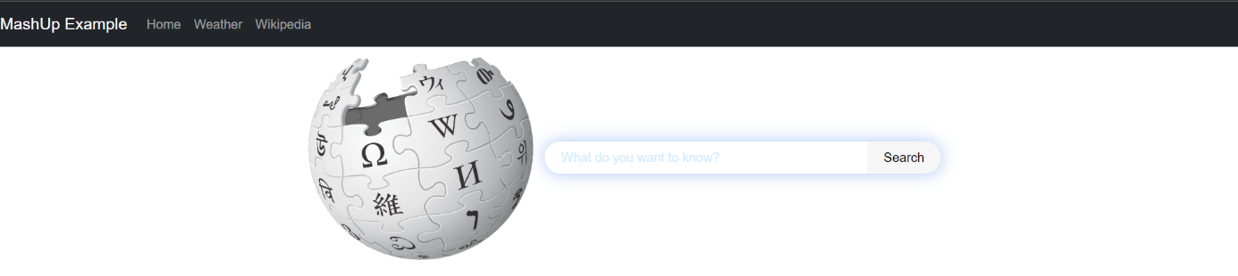

Figure Initial view after clicking on the Wikipedia menu

Then after we search for an article (Sweden example), through the Wikipedia API it shows us all the articles that Wikipedia has about Sweden.

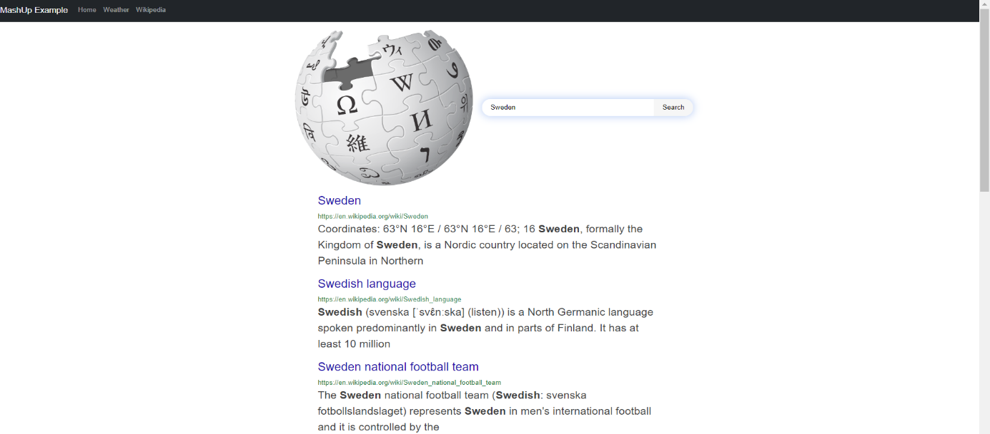

Figure Sweden example

While the code that allows us access to Wikipedia's API is presented below.

# 

# Conclusions and Reflections

From everything that has been stated so far, we can come to a conclusion that a Mashup (also known as a hybrid web application), is a technique that websites use to provide resources, functionality and services from multiple sources. To put it in layman's terms, a mashup works as an aggregator of different services. In this paper, the author has presented three different services where he received different data through their APIs. This paper presents a complete analysis of the use of these services, what we can achieve through the use of APIs, what future awaits us from weather forecasting, the data we need and which wikipedia possesses, authentication and security. In conclusion, author can stated that an API mashup consists of one or more mashup steps, and each step invokes an API.

# REFERENCES

Liu, X., Hui, Y., Sun, W., & Liang, H. (2007). Towards Service Composition Based on Mashup. *School of Electronics Engineering and Computer Science, Peking University, Beijing, China 100871.* IBM China Research Lab, Beijing, China, 100094.

Meng, M., Steinhardt, S., & Schubert, A. (2018). Application Programming Interface Documentation: What Do Software Developers Want? *Journal of Technical Writing and Communication: Volume 48, Issue 3, July 2018, Pages 295-330.*

Nakayama, K., Pei, M., Erdmann, M., Ito, M., Shirakawa, M., Hara, T., & Nishio, Sh., (2008). Wikipedia Mining. Wikipedia as a Corpus for Knowledge Extraction. *Dept. of Multimedia Eng., Graduate School of Information Science and Technology. Osaka University, Japan.*

Musah, A., Dutra, L., Aldosery, A., Browning, E., Ambrizzi, T., Pinheiro, W., Tunali, M., Campos, L., Lima, C., Silva, A., Moreno, G., Yenigun, O., & Massoni, T., (2022). An Evaluation of the OpenWeatherMap API versus INMET Using Weather Data from Two Brazilian Cities: Recife and Campina Grande.

Corner, M., & Noble, B., (2003). Proceedings of MobiSys2003: The First International Conference on Mobile Systems, Applications and Services. *USENIX Association. Protecting Applications with Transient Authentication.* University of Michigan.